WHITEMAN AFB, MO
PUBLIC HEALTH

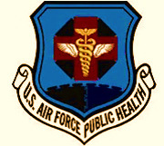
PUBLIC HEALTH NOTICE

This food booth has been inspected by Whiteman AFB, Public Health Element using the following standards:

AFMAN 48-147, Chapter 10
TEMPORARY, SEASONAL, AND VENDING FOOD OPERATIONS

If there are any questions/concerns, please contact Public Health at (660)687-4305.

